**Level 0: Personal Computer Internals**

1. Create a labeled diagram of the inside of a typical personal computer.
   1. You can do it electronically or on paper.
   2. The diagram cannot be a single clip art from the web but may use individual images from the web.
   3. The labels and arrows to the various components must be drawn by you.

Some computer components are :

The main components are:

Processor:

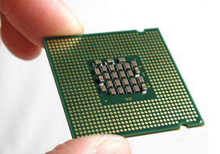

Main memory:

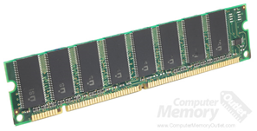

Secondary memory:

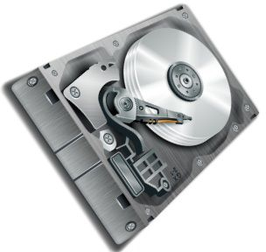

Input devices:

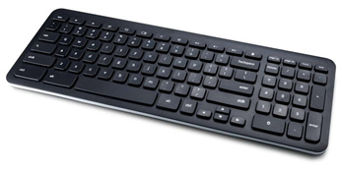

Output devices:

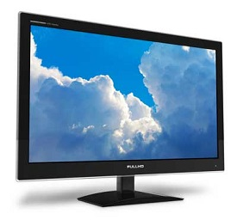

Motherboard:

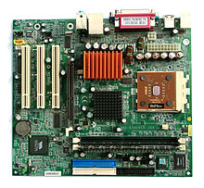

Graphics processing unit:

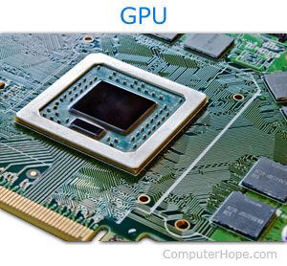

Power supply:

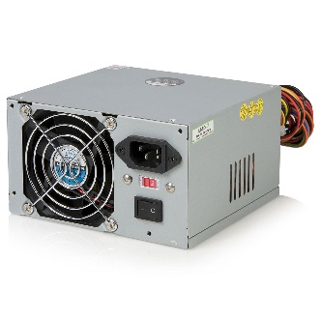

Case

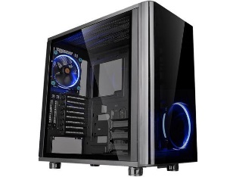

1. Labeling the Motherboard.
   1. Show the location of the CPU and CPU Fan.

CPU 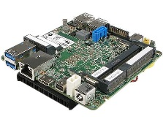 CPU Fan 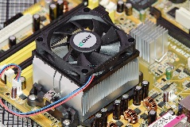

* 1. Show the location of the Memory Slots and RAM Memory

Memory slots 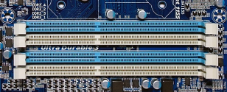 RAM Memory 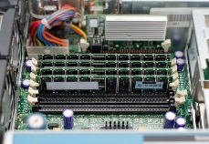

* 1. Show the location of the on-board video, sound, Ethernet/Wireless and USB devices

ON-board video 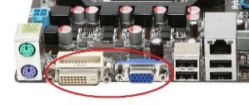 Sound 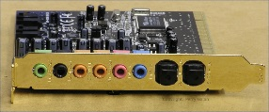 Ethernet 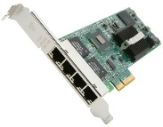

USB Devices 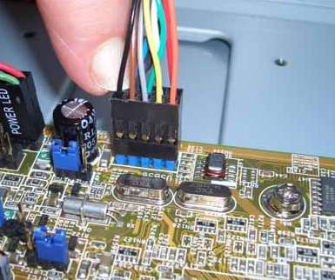

* 1. Show the location of the expansion slots and Video and Sound boards.

Expansion slots: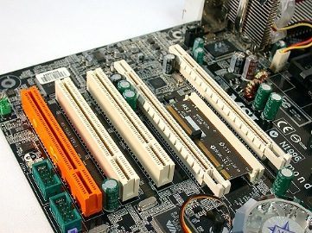 Video: 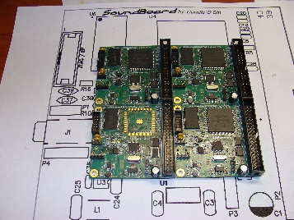

1. Labeling the Chassis Components.
   1. Show the location of Power Supply.

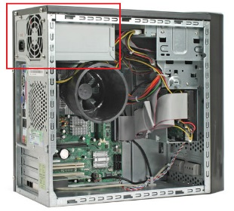

* 1. Show the location of the External Hard Drives and connections to the Motherboard

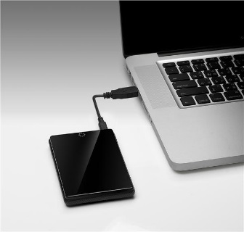

* 1. Show the location of the Removable Media Drives and connections to the Motherboard

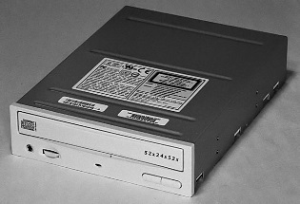

* 1. Show and label the external connector plate (i.e. where the monitor, keyboard, etc. are connected.)

